Jotmans Hall Primary School
Additional Funding Strategy Document
2021-22

Incorporating Pupil Premium, Recovery Premium, National Tuition Funding, Sports Premium, School Mentor

The purpose of this document is to outline the additional funding streams available to the school. It endeavours to outline the long term and short strategies for Jotmans Hall School, applicable to each funding stream. The aim is to give an overview of the work linked to each strategy that is being carried out within Jotmans Hall Primary School
The specific costings and impact of each strategy is broken down further in the following documents:
- JHS 3-year pupil premium strategy
- Pupil Premium Strategy
- Sports Premium Strategy

Schools are learning organisations. They continuously strive to do better for the children and young people in their charge. In doing so, they try new things, seek to learn from those experiences, and work to adopt and embed the practices that work best.
PUTTING EVIDENCE TO WORK: A SCHOOL’S GUIDE TO IMPLEMENTATION from the Education Endowment Foundation

Purpose of Funding Strategies (from gov.uk):
Pupil Premium
Pupil premium is funding to improve education outcomes for disadvantaged pupils in schools in England. Evidence shows that disadvantaged children generally face additional challenges in reaching their potential at school and often do not perform as well as other pupils.
Budget Allocation:
£62,447 plus £2,795 brought forward from 2020-21 = £65,242
Recovery Premium
In February 2021, the government announced a one-off recovery premium as part of its package of funding to support education recovery.
The recovery premium provides additional funding for state-funded schools in the 2021 to 2022 academic year. Building on the pupil premium, this funding will help schools to deliver evidence-based approaches for supporting disadvantaged pupils.
Budget Allocation:
£6,525
The National Tutoring Programme
The National Tutoring Programme (NTP) is an ambitious scheme intended to provide additional, targeted support for those children and young people in schools who have been most affected by disruption to their education as a result of the coronavirus (COVID-19) pandemic.
During the first year of the programme introduced in November of the 2020 to 2021 academic year, state-maintained primary and secondary schools in England were able to access high-quality subsidised tutoring provision for 5 to 16-year-olds using 2 routes, tuition partners and academic mentors. (As an academy, we were not eligible to this funding.)
The second year covers the 2021 to 2022 academic year and builds on the first phase. Based on feedback from schools, we have expanded the NTP for the second year of the programme, offering state-funded schools and academy trusts 3 routes to tutoring:
- tuition partners
- academic mentors
- school-led tutoring
Budget Allocation:
£6,682.50
Academic Mentor
In summer 2020, the government announced the National Tutoring Programme (NTP) to help support disadvantaged pupils to catch-up on missed learning. One pillar of NTP is the academic mentor programme.
Academic mentors will support one-to-one and small-group, subject-specific tuition. They may also support revision lessons and provide additional support for pupils shielding or not in school. Academic mentors will be a part of their school’s staff team and will be supported and managed by the school to deliver tutoring that is appropriate, timely, and linked to their curriculum.
Budget Allocation:
Approximately £7,500
Sports Premium
Schools must use the funding to make additional and sustainable improvements to the quality of the PE, physical activity and sport they provide. This includes any carried forward funding.
This means that you must use the PE and sport premium to:
- develop or add to the PE, physical activity and sport that your school provides
- build capacity and capability within the school to ensure that improvements made now are sustainable and will benefit pupils joining the school in future years
Budget Allocation:
£18,690

Current School Position:
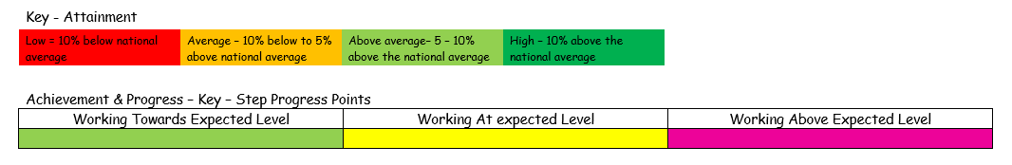

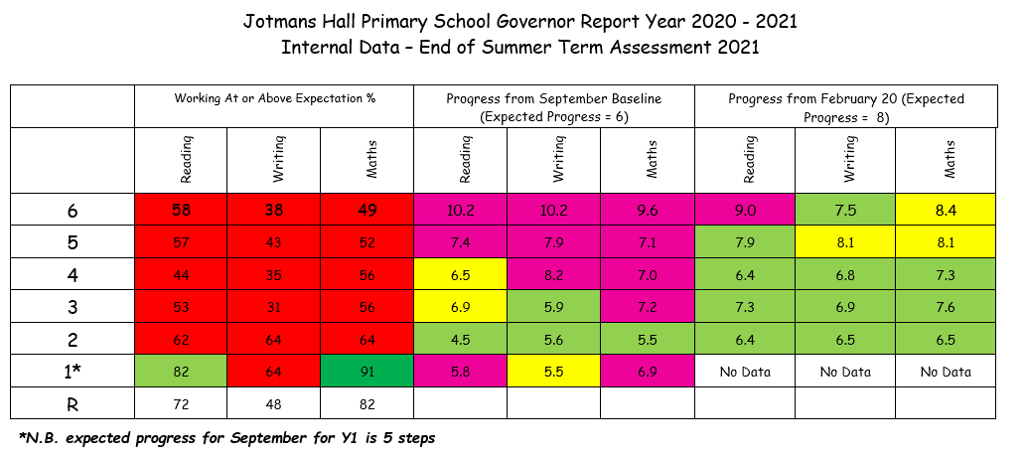
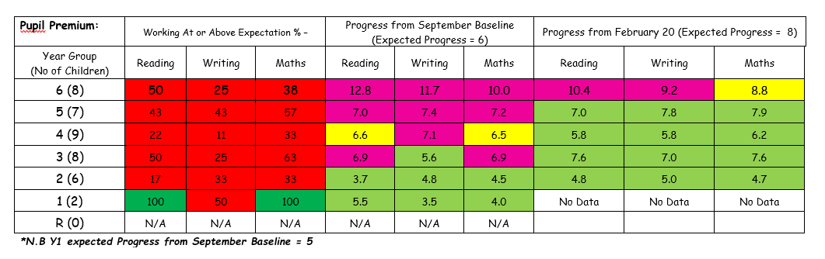
Issues raised from 2020-21 data
- All year groups are below age expectation in Writing, with pupil premium being below non-pupil premium
- All year groups (except current Year 2) are below age expectation in Reading
- All year groups (except current Year 2) are below age expectation in Maths
- Current Year 5 and 3 pupil premium children are below non-pupil premium children in all subjects.

SDP priorities
Objective 1 | To continue to develop the curriculum to ensure it is broad and balanced, so that it has a positive impact on every pupils’ progress.
Objective 2 | To develop a coherent Whole School strategy document incorporating PPG, Recovery premium, sports premium and 1:1 tuition.
Objective 3 | To develop all staff and governors understanding of Ofsted inspection requirements and use this understanding to further enhance pupils’ progress.
Objective 4 | To ensure that phonics and reading remain a high priority throughout the school.

Pupil Premium & Recovery Premium – 3year Long Term Plan
 | Link to SDP
Improving quality of teaching – metacognition and self-regulation

Actions 2021-22
- Staff training on metacognition strategies | Objective 1
- CGP workbooks purchased for all year groups to support Catch-up interventions.
Rapid and sustained progress made in reading and phonics for all pupils, including disadvantaged and SEND.

Actions 2021-22
- Reading & Phonics intervention strategies for Year 1 and children not achieving age expectation through LSA team. | Objective 1, 4
- Additional LSA support to deliver a timetable of intervention strategies each afternoon. | Objective 1, 4
Developing a robust pastoral support system within the school, including developing the Behaviour Management System to ensure consistency in approach across all staff.

Actions 2021-22
- Whole Staff training for behaviour management strategies | Objective 1
- BATIC counselling funded for students, families and staff
- Additional LSA support to deliver a timetable of intervention strategies each afternoon.
- Attendance consultants to help monitor attendance and persistent absence
- Head teacher to complete Mental Health Lead training
- Becoming a Mental Health Support Team Training School
- Anti-Bullying Ambassador training attended by Head teacher, Staff and pupils
Individually tailored strategies to support disadvantaged children with specific challenges

Actions 2021-22
- Breakfast regularly provided for two students | Objective 1
- School uniform and basic equipment supplied
- Trips funded
- Clothing items for a residential trip supplied
- After school clubs funded
- Taxis provided to and from school
- Swimming lessons funded
- Transport for parents to attend school based meetings provided
- Laptops supplied for use at home (DfE funded)

National Tuition Programme

Actions 2021-22 | Link to SDP
- From November 2021, a tutor (a qualified teacher) has been used to run sessions with groups of children from Years 2, 3 and 4 to support Reading Recovery. Those chosen were not making satisfactory progress with their reading. This support was for two days a week. | Objective 1, 4
- From January 2022 additional tutoring in Maths and Literacy for Year 6 pupils. This support took place for 11 weeks before and after school in the lead up to their SATs exams. | Objective 1

Academic Mentor

Actions 2021-22 | Link to SDP
- From January 2022 an Academic mentor (a qualified teacher) has been employed three days a week. The focus has been to support individual reading skills for SEND and PP children in all year groups. | Objective 4

Sports Premium (Please see the Sports Premium Full Report)

Actions 2021-22 | Link to SDP
- Membership to the CPRSSP
- Specialised Sports Coaches to support curriculum learning
- To update and maintain resources
- Swimming pool maintenance
- Staff CPD
- Extra-curricular clubs
- Transport costs, to and from sporting events

