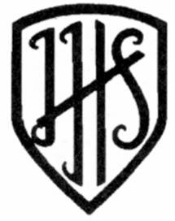

Jotmans Hall Primary School

School Uniform Statement

- Introduction
It is our school policy that all children wear school uniform when attending school, or when participating in a school-organised event outside normal school hours. In a recent survey (Feb 2022) to parents, 98% of parents agreed there should be a school uniform at Jotmans Hall School.

We have a gender neutral school uniform, with some branded items supplied Penn UK. Non-branded alternatives are also acceptable. (Please see point 7 – School Uniform Options - for further information.)

- Aims and Objective
We feel school uniform is important because it:
- promotes a sense of pride in the school
- engenders a sense of community and belonging towards the school
- is practical and smart
- prevents children from coming to school in fashion clothes that could be distracting in class.
- makes children feel equal to their peers in terms of appearance
- is regarded as suitable wear for school and good value for money by most parents
- is designed with health and safety in mind

- Jewellery
We strongly recommend that children do not wear any jewellery to school due to health and safety concerns. An ‘earring disclaimer’ can be signed to allow small earring studs in pierced ears on non-PE days.
Small items of religious significance, (such as a crucifix on a chain), may be permitted. If you wish your child to wear an item of religious significance you must apply in writing to the head teacher.
No jewellery items are permitted on PE/ Swimming days.

4. Extreme Haircuts
The school does not permit children to have ‘extreme’ haircuts or unnatural hair colours that could serve as a distraction to other children.

5. Footwear
The school wants all children to grow into healthy adults. We believe that it is unsafe for children to wear shoes that have open toes, sling backs, platform soles or high heels at school, so these are not permitted. Children are allowed to wear trainers to school on their PE days only; this is because we think that this footwear is appropriate for sport or for leisurewear, but is not in keeping with the smart appearance of a school uniform. We require all children to wear shoes as stated in the uniform list.

6. The Role of Parents
We ask all parents who send their children to our school to support the School Uniform Policy. The school welcomes children from all backgrounds and faith communities. If there are reasons, for example on religious grounds, why parents want their child to wear clothes that differ from the school uniform, the school will look sympathetically at such requests.

7. School Uniform Options

Reception / Year 1
      - White shirt / polo t-shirt
      - Plain grey skirt / culottes / dress / tailored trousers / shorts
      - Burgundy sweatshirt / cardigan (Jotmans Hall logo optional)
      - Sensible black shoes and white or grey socks / tights
Year 2 – 6
      - White shirt
      - Plain grey skirt / culottes / dress / tailored trousers / shorts
      - Burgundy sweatshirt / cardigan (Jotmans Hall logo optional)
      - School tie
      - Sensible black shoes and white or grey socks / tights

Hot weather variations- All year groups
- Pink checked summer dress

Physical Education
All children need PE clothing, which we ask them to wear to school for the day, on their P.E. / Swimming days. You will be informed about which day this is, once the term starts and the timetables have been finalised. School P.E. kit is as follows…

- Black Plimsolls (slip-on type if child cannot handle laces) or Plain Black or White trainers
- Burgundy shorts and white t-shirt (Jotmans Hall logo optional)
- Light grey jogging suit (Jotmans Hall logo optional)

Branded school uniform is supplied by Penn UK who are located at 15 Kents Hill Road, SS7 5PN. Parents are able to purchase uniform Monday-Friday 9:00-5:30 and Saturday 9:00-12:00 or securely online at www.pennuk.com

Plain uniform options (without the school logo) are also acceptable, and can be purchased from many supermarkets, department stores etc.

School ties are also available to purchase from the school office.

The school holds regular ‘Nearly New Sales’, where good quality, second-hand uniform can be bought at a reasonable price.
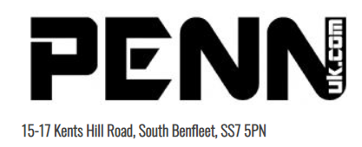

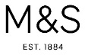

8. The Role of Governors
The Governing Body supports the Headteacher in implementing the School Uniform Policy and liaises with the Headteacher to ensure that the Policy is implemented fairly and with sensitivity.

It is the Governors’ responsibility to ensure that the school uniform meets all regulations concerning equal opportunities.

Governors ensure that the School Uniform Policy helps children to dress sensibly, in clothing that is hardwearing, safe and practical.

9. Monitoring and Review
The Governing Body monitors and reviews the School Uniform Policy through its committee work by:

- considering, with the Headteacher, any requests from parents for individual children to have special dispensation with regard to school uniform.

- requiring the Headteacher to report to the Governors on the way the School Uniform Policy is implemented.

Written: May 2022
To Be Reviewed: May 2023

