Jotmans Hall Primary School
Headteacher’s Newsletter
Spring 1 2021

I would like to begin this newsletter by thanking you and all the children of Jotmans Hall for your fantastic support and positivity during this lockdown. I know that home schooling brings many challenges, but the response from everyone has been magnificent.
As you will be aware the Prime Minister announced that the 8th March 2021 is the earliest that the school will reopen, and once we have more information about the Government’s plans I will be in touch with you all.
It was good to know that so many of you were able to meet with your child’s class teacher during our first Virtual Parent Consultations. Inevitability, there were a few teething problems, and apologies if you encountered any of those.
While the school has been quiet we have taken the opportunity to make some improvements. All the toilets have been painted, so they all look a lot brighter. Other areas around the school have also had a lick of paint, so we are looking a lot smarter in places!
The kitchen have also been spending the time developing new meals for the lunch menu. We’ve been lucky enough to have a few tasters and there are definitely some treats in store for the children when we are eventually back together.
Here’s wishing you a very restful half term break………..and fingers crossed we are all back together soon.
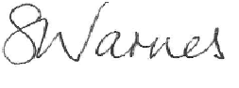

Headteacher

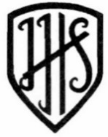

News:
BORIS THE LOCKDOWN LEVERET
Thank you to everyone who designed a lock for Boris the Lockdown Leveret. I’m pleased to say he has been decorated and will soon be on his way to Southend. Over the summer he will take place in a trail that everyone can take part in, all taking place to raise money for Haven’s Hospice. For more information go to https://www.haresabouttown.co.uk/
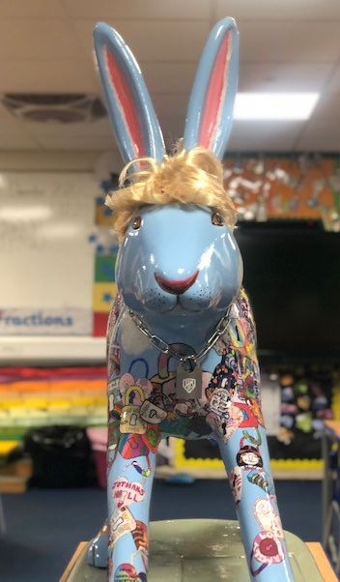

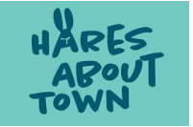
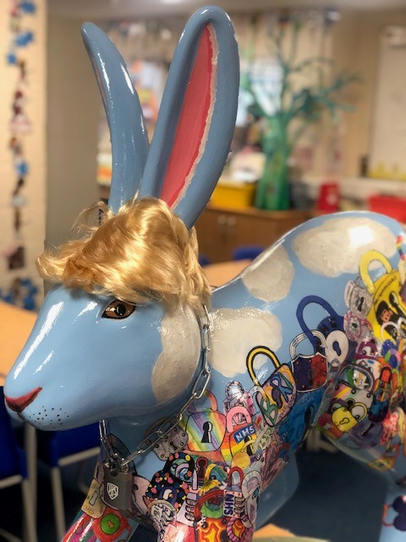

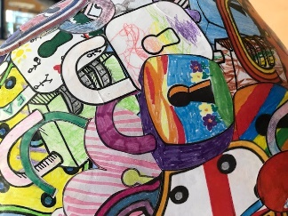

Check out these top tips for learning at home
To help stop the spread of coronavirus, schools across the UK have temporarily moved to online learning.
Home-learning expert Tom Crombie from My Online Schooling has sent Newsround some of his best tips
https://www.bbc.co.uk/newsround/55705092
World Book Day 2021
We will be celebrating World Book Day in March. More information to follow…….

HAPPY NEW YEAR
We would like to wish you all a very happy Chinese New Year. This year is the Year of the Ox
There is a cycle of animals which repeats every 12 years, and 2021 is the turn of the Ox. Different characteristics are assigned to each animal, and this is traditionally used to determine fortune. The ox, for example, is associated with hard work and serenity and I think, I’m safe to say, we would all like this year to be much more serene.
For more information please go to: https://www.bbc.co.uk/newsround/38668427

COLLECTING STAMPS
Please remember to carry on collecting your stamps – we are collecting them for a worthy cause – The Bone Cancer Research Trust.
These can be dropped off in the box outside the school office or hold on to them until we are all back in school. 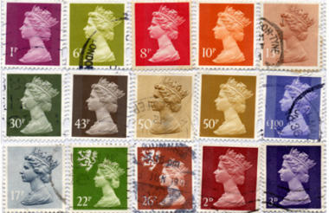

We hope to see you all very soon
STAY SAFE

